Title of Manuscript

Max Mustermann* and Michaela Mustermann**

Abstract

This is a sample abstract in English. This is a sample abstract in English. This is a sample abstract in English. This is a sample abstract in English. This is a sample abstract in English. This is a sample abstract in English. This is a sample abstract in English. This is a sample abstract in English.

Keywords: Keywords, Keywords Keywords, Keywords
JEL Classification: JEL, JEL, JEL

I. This is a Headline

This is text on level 1. This is text on level 1. This is text on level 1. This is text on level 1. This is text on level 1. This is text on level 1. This is text on level 1. This is text on level 1. This is text on level 1. This is text on level 1.

This is a Headline
This is text on level 2. This is text on level 2. This is text on level 2. This is text on level 2. This is text on level 2. This is text on level 2. This is text on level 2. This is text on level 2. This is text on level 2. This is text on level 2.

- This is a Headline

This is text on level 3. This is text on level 3. This is text on level 3. This is text on level 3. This is text on level 3. This is text on level 3. This is text on level 3. This is text on level 3. This is text on level 3. This is text on level 3.
Citation
The structure of citations should be consistent. Names of authors quoted in the text or in footnotes are to be italicized. Several successively quoted names must be separated by slashes. Several sources must be separated by a semicolon. Example:
- A clear trend (Müller 1998)…
- A clear trend (Müller/Meyer 1998)…
- A clear trend (Müller/Meyer 1998; Berger et al. 1995; Cole 2004)…
- As Müller (1998) describes…
- As Müller/Meyer (1998) describe…
Kindly follow for the list of bibliographic references the following example: Zobel, M./Wolf, A. (2013): Title, Journal, 100.
Citations that are generally known or apparent from context can be shortened (European Central Bank=ECB). Otherwise the abbreviation has to be spelled in full at least one time.
Sources, like the ECB, BBC, APP, PSPP, Deutsche Bundesbank, European Commission, etc. are not to be italicized. Likewise, no other words in the text may be highlighted through italics. Also “et al.” should not be written in italics. ONLY the last names of the author(s) and journal, newspaper and magazine titles (NOT article titles) are to be italicized. The same applies to mathematical formulas.
Missing data for citation:
- Without date: Author (n.d.)
- Without author: start with the Article title.
- Anonymous Author: Anonymous (2020).

Table 1
Standard VAT rate Before and During the EMU
 | VAT Stand. rate  pre-EMU | VAT Stand. rate  During EMU | Change*
Austria | 20% | 20% | -
Belgium | 21% | 21% | -
Cyprus | 10% (2002); 15% | 18% | 8% (2002); 3%
Estonia | 18% (2002); 20% | 20% | 2% (2002); -
Finland | 22% | 24% | 2%
France | 19.6% | 19.6% | -
Germany | 16% | 19% | 3%
Greece | 18% | 23% | 5%
Ireland | 20% | 23% | 3%
Italy | 20% | 21%; 22% (07/1/13) | 1% (2002); 2%
Luxembourg | 15% | 15% | -
Malta | 15% (2002); 18% | 18% | 3% (2002); -
The Netherlands | 19% | 19%; 21% (10/1/12) | -; 2% (10/1/12)
Portugal | 17% | 23% | 6%
Slovak Republic | 19% | 20% | 1%
Slovenia | 20% | 20% | -
Spain | 16% | 21% | 5%
Aver. (2002-2012) | 18% | 20.39% | -
Aver. (EMU adh. -2012) | 18.45% | 20.39% | -
Note(s): This is a note. *This is a note aswell.
Source(s): European Commission (2012).

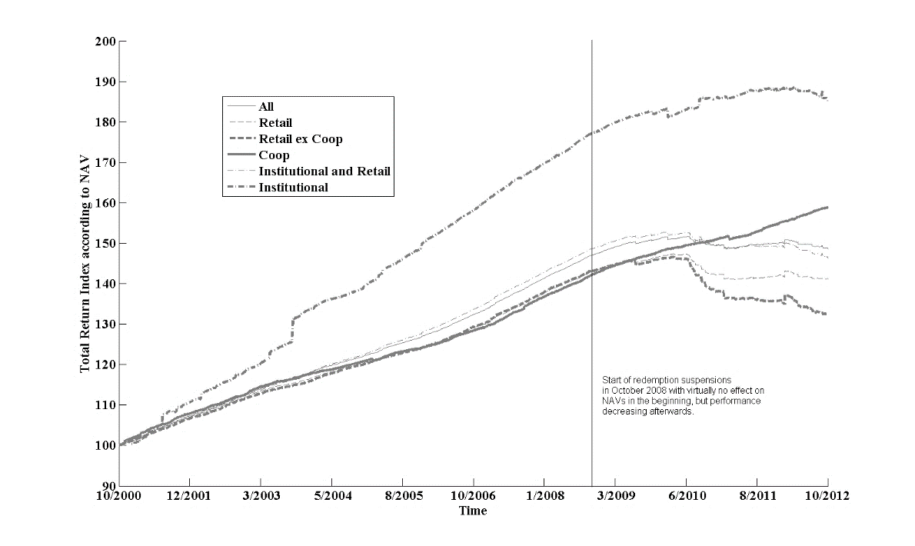
Note(s): This is a note. *This is a note as well.
Source(s): ECB SDW.

Figure 1: Index of GOEREF Groups When Using NAV

References

Beckmann, J./Belke. A./Kühl, M. (2011): The Dollar-Euro Exchange Rate and Macroeconomic Fundamentals: A Time-varying Coefficient Approach, Review of World Economics, Vol. 147(1), 11-40.
Beckmann, J. (2013): Nonlinear Adjustment, Purchasing Power Parity and the Role of Nominal Exchange Rates and Prices. North American Journal of Economics and Finance, Vol. 24(1), 176-190.
Beckmann, J./Czudaj, R. (2013): Oil Prices and Effective Dollar Exchange Rates. International Review of Economics & Finance, Vol. 27(1), 621-636.
Bilson J. (1978): The Current Experience with Floating Exchange Rates: An Appraisal of the Monetary Approach, American Economic Review, Vol. 68(2), 392-397.

* Prof. Dr. Max Mustermann, University of Hohenheim, Chair of Banking, Street 123, 01234 Stuttgart, E-Mail: max.mustermann@uni-hohenheim.de
** Prof. Dr. Michaela Mustermann, University of Hohenheim, Chair of Banking, Street 123, 01234 Stuttgart, E-Mail: Michaela.mustermann@uni-hohenheim.de
This is a footnote.

